SoulBound Tokens Deployment

Swati Jadhav  
*Department of Computer Engineering, Vishwakarma Institute of Technology Pune, India*

[swati.jadhav21@vit.edu](mailto:shraddha.bagav21@vit.edu)

Himanshu Bhatia  
*Department of Computer Engineering, Vishwakarma Institute of Technology Pune, India*

[himanshuu.bhatia21@vit.edu](mailto:himanshuu.bhatia21@vit.edu)Shraddha Bagav  
*Department of Computer Engineering, Vishwakarma Institute of Technology Pune, India*

[shraddha.bagav21@vit.edu](mailto:shraddha.bagav21@vit.edu)

Amey Dhuri  
*Department of Computer Engineering, Vishwakarma Institute of Technology Pune, India*

[amey.dhuri21@vit.edu](mailto:amey.dhuri21@vit.edu)

Prajwal Kadam  
*Department of Computer Engineering, Vishwakarma Institute of Technology Pune, India*

[prajwal.kadam21@vit.](mailto:prajwal.kadam21@vit.edu)

***Abstract*** – **A blockchain is a distributed software network that serves as a digital record as well as a platform for the safe transfer of assets without the use of an intermediary. On a blockchain network, anything from currency to land titles to votes may be transferred, tokenized, stored, and traded. As Bitcoin is the digital solution to currency, NFTs are now being marketed as the digital answer to collectibles. They are known as Soul Bound Tokens or Non-Transferable Tokens (NFTs). An SBT is a type of NFT that is linked to a soul address that is unique to each individual (also referred to as a soul). Hence our goal is to create Soulbound tokens**

**that are a type of NFT, but they differ in one major way — they are designed never to be transferred. For example, a user credential encoded within a soulbound token should be linked to a particular user, not transferable to any account on the blockchain using remix, metamask, opensea, solidity, polygon test tokens.**

***Keywords*— NFTs, SBTs, Blockchain.**

I. INTRODUCTION

A new non-transferable, publicly verifiable digital token initiative called SoulBound can serve as an indicator of someone's rank on web 3. On the web3, SBTs might act as a kind of digital CV for a person. The new non-transferable NFTs would include all information about memberships, affiliations, and credentials of an individual. Since Soulbound Tokens can be a key to solve the trust issue, the project platform focused on easy to deploy , transfer and view Soulbound Tokens(SBT) because The trust factor is currently the most important problem affecting the web3 landscape. The trust factor is now the most important problem influencing the web3 ecosystem.On the other hand, web3 has to deal with critical issues in this domain due to considerably higher privacy and anonymity in web3 applications.

II . LITERATURE SURVEY

Web3 today centers around expressing transferable, financialized assets, rather than encoding social relationships of trust[1] so the non-transferable “soulbound” tokens (SBTs) representing the commitments, credentials, and affiliations of “Souls” can encode the trust networks of the real economy to establish provenance and reputation for example An individual's identity is made up of a variety of information, including their job, volunteer, and educational backgrounds, their credentials, their medical and criminal histories, their memberships and affiliations, and much more. Moreover (DeSoc)- “Decentralized Society” which brings in trust through dependable sources to provide a CV/Credit report that can live-update the risk or legitimacy of individuals and businesses. SBTs enable other applications of increasing ambition, such as community wallet recovery, sybil-resistant governance, mechanisms for decentralization, and novel markets with decomposable, shared rights[1]. Since Soulbound Tokens can be a key to solve this trust issue, the project creates a Platform where it is easily possible to deploy, transfer and view Soulbound tokens (SBT).SBTs could make it possible for us to effectively represent and manage assets and products that fall somewhere between entirely private and fully public.

III . PROPOSED SYSTEM

The proposed system focuses on creating and sending SBTs to the user's wallet so that it may serve as the user's identity. The SBTs will be produced using smart contracts, and transactions involving those SBTs will be made from one address to another using a Metamask wallet.

A. Block Diagram

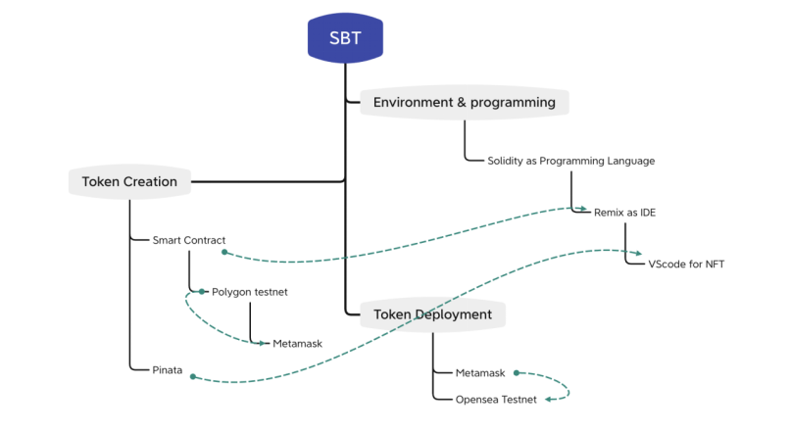

Fig. 1. Block Diagram

Figure 1 depicts the entire block design of the system and all the key points for Token deployment includes the Metamask for wallet and OpentestNet for buying, selling, and NFTs, using smart contracts since it is a decentralized, blockchain-based platform Smart contracts are programmed to ensure that there is no cheating on the platform, and creators can sell their tokens at whatever price they deem fit. A cryptocurrency token is a token or a cryptocurrency's denomination. It represents a tradable asset or utility that resides on its own blockchain and allows the holder to use it for investment or economic purpose.

IV. STEPS

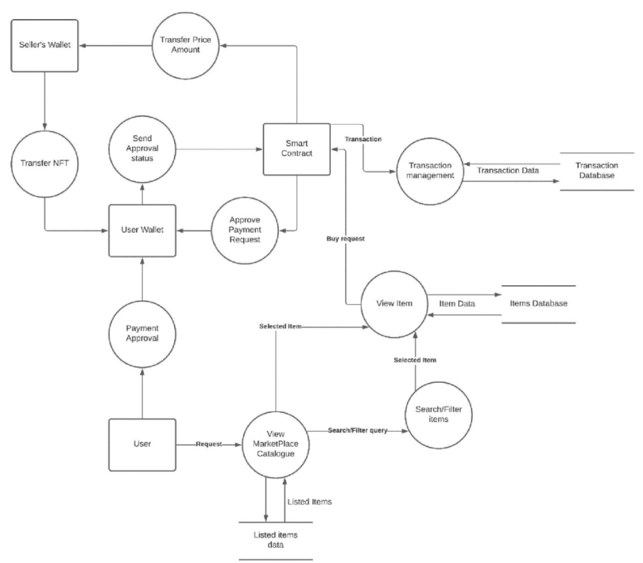

Fig 2 : DataFlow Diagram

A data flow diagram (DFD) maps out the flow of information for processes . Smart contract is use to create SBTs and from mettamasks wallet accounts i.e. from one address to another address the SBTs would be placed. After the Soul token or SBT is issued to a particular address or Soul, it can view the token using the OpenSea platform. OpenSea keeps track of all transactions made on the Ethereum network using smart contracts.The user must have a metamask wallet to get the created SBT.

V. CONCLUSION

SBTs provide a wide range of applications to improve current Web3 usage. Large-scale decentralization was one of the goals of Web3, but it still presents a formidable challenge. The changes that can be implemented to Web3 governance because of SBTs without falling back into Web2 architecture will prevent whale dominance and drastically limit sybil attacks. Additionally, active community members will be able to demonstrate their interest and will be compensated appropriately.SBTs can also significantly advance prediction markets, crypto gaming, and the financial capabilities of Web3 DeFi organizations through creating less of an emphasis on transferability, and building reputations. They solve the identity problems that limit Web3, paving a way for Web3 to become more useful to our everyday lives than ever before.

VI. REFERENCES

[1] **Weyl, Eric Glen and Ohlhaver, Puja and Buterin, Vitalik, Decentralized Society: Finding Web3's Soul (May 10, 2022). Available at SSRN:** [**https://ssrn.com/abstract=4105763**](https://ssrn.com/abstract=4105763) **or** [**http://dx.doi.org/10.2139/ssrn.4105763**](https://dx.doi.org/10.2139/ssrn.4105763)

[2][**https://nftnow.com/guides/soulbound-tokens-sbts-meet-the-tokens-that-may-change-your-life/**](https://nftnow.com/guides/soulbound-tokens-sbts-meet-the-tokens-that-may-change-your-life/)

[3][**https://www.coindesk.com/learn/what-are-soulbound-tokens-the-non-transferrable-nft-explained/**](https://www.coindesk.com/learn/what-are-soulbound-tokens-the-non-transferrable-nft-explained/)

[4][**https://dev.to/envoy_/what-are-soulbound-tokens-14lj**](https://dev.to/envoy_/what-are-soulbound-tokens-14lj)

[5][**ttps://lcxwire.com/soulbound-token-sbt-whitepaper-pdf-on-decentralized-society-finding-web3s-soul-with-non-transferable-soulbound-nfts/**](https://lcxwire.com/soulbound-token-sbt-whitepaper-pdf-on-decentralized-society-finding-web3s-soul-with-non-transferable-soulbound-nfts/)